STUDENT PERFORMANCE
ANALYTICS SYSTEM
Project Documentation

1. Project Title
Project Name: Student Performance Analytics System
Student Name: Harinam jee
Course: Python with AI
Department: Computer Science and Engineering (CSE)
Technologies: Python, NumPy, Pandas

2. Objective
The objective of this project is to develop a Python-based Student Performance Analytics System that analyses students' marks and attendance. The project reduces manual calculations by automatically calculating total marks, average marks, grades, and pass/fail results. It also identifies the highest- and lowest-performing students, calculates the overall class average, compares performance across subjects, and identifies top-performing students. The system helps users understand student performance and identify students who may need improvement.

3. Technologies Used
- Python: Implements program logic, conditions, loops, and functions.
- Pandas: Loads CSV files, creates DataFrames, organises records, and analyses data.
- NumPy: Performs numerical calculations such as totals, averages, maximums, and minimums.
- CSV: Stores student records in a structured tabular format.
- Visual Studio Code: Used to write and execute the Python program.
- GitHub: Used to store and share the completed project online.

4. Dataset Description
The project uses a dataset of 20 student records. The dataset is created using Python and saved as 'students.csv'. It is then loaded into a Pandas DataFrame for processing and analysis.
- Student_ID: Unique identification number for each student.
- Name: Student's name.
- Department: Student's department.
- Python: Marks obtained in Python.
- Maths: Marks obtained in Mathematics.
- DBMS: Marks obtained in Database Management Systems.
- Attendance: Student attendance percentage.
The program adds calculated columns such as Total, Average, Grade, and Result to the analyzed dataset.

5. Implementation
- Dataset Creation: Create 20 student records and save them in students.csv.
- Data Loading: Use pandas.read_csv() to load the CSV file into a DataFrame.
- Numerical Calculations: Use NumPy to calculate totals, averages, subject averages, and maximum/minimum values.
- Functions and Loops: Create reusable functions for grades and pass/fail results, and use loops when iterating through subjects or records.
- Total and Average: Calculate each student's total marks and average marks across the selected subjects.
- Grade Assignment: Assign grades based on a predefined grading rule.
- Pass/Fail Identification: In the example implementation, a student passes if they score at least 40 marks in every subject.
- Performance Analysis: Find the highest student average, lowest student average, and overall class average.
- Subject-Wise Analysis: Calculate average marks for Python, Maths, and DBMS to identify the subject with the highest average.
- Top Performers: Sort students by average marks and identify the top three students.
- Save Results: Save the analysed records to student_analysis.csv.

6. Key Features
- Creation of a dataset containing 20 student records.
- Loading and organising data using a Pandas DataFrame.
- Numerical calculations using NumPy.
- Reusable functions for grades and pass/fail results.
- Use of loops and conditional statements.
- Automatic calculation of total and average marks.
- Grade assignment based on average marks.
- Identification of passing and failing students.
- Calculation of highest, lowest, and overall average performance.
- Subject-wise performance analysis.
- Identification of the top three students.
- Export of analysed results to a CSV file.

7. Output / Screenshots
The program displays the original student dataset and calculated results in the terminal. The output includes student names, total marks, average marks, grades, and pass/fail status. It also displays class performance statistics, subject-wise averages, and the top three students.
Insert actual screenshots from your program in the spaces below:
Screenshot 1: Original dataset containing student records.
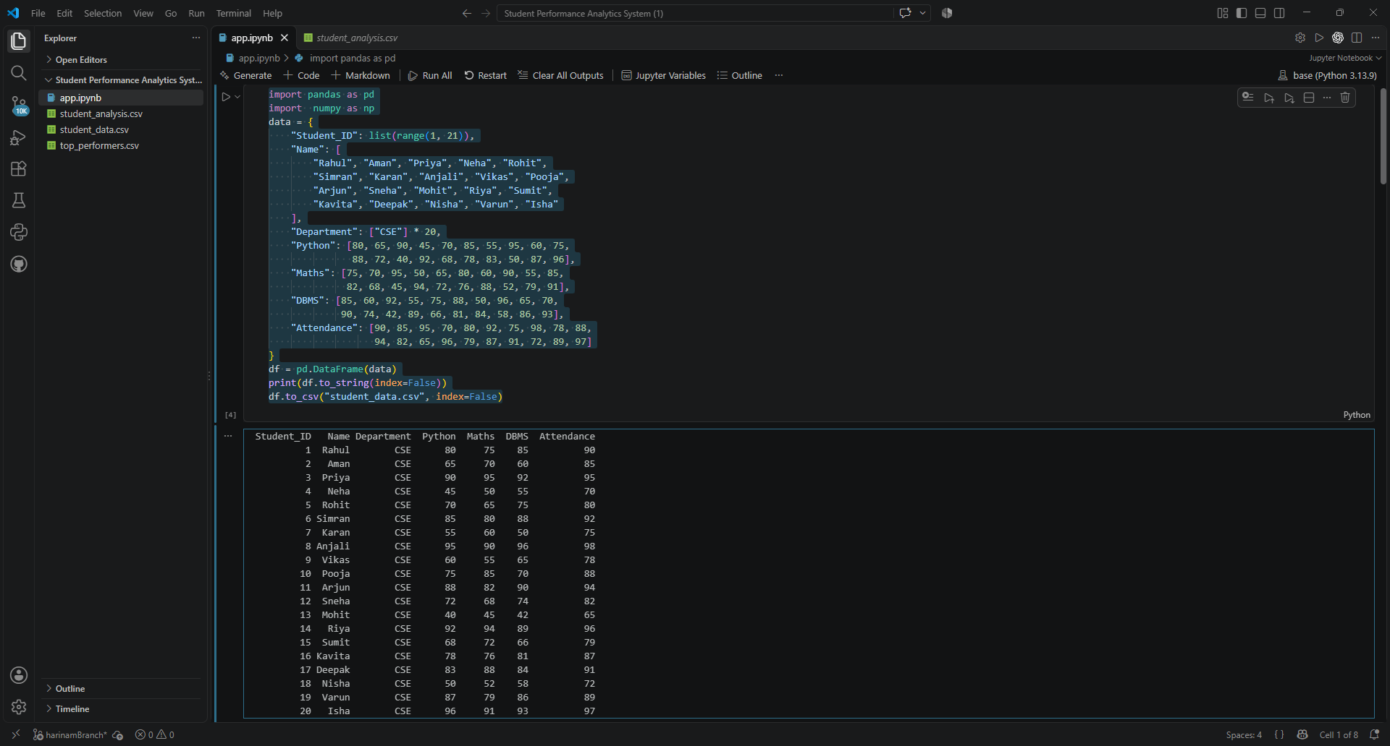
Screenshot 2: Total marks, average marks, grades, and pass/fail results.
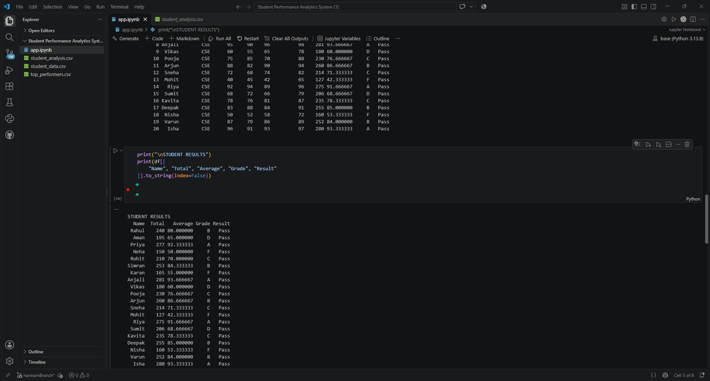
Screenshot 3: Highest, lowest, and overall class average.
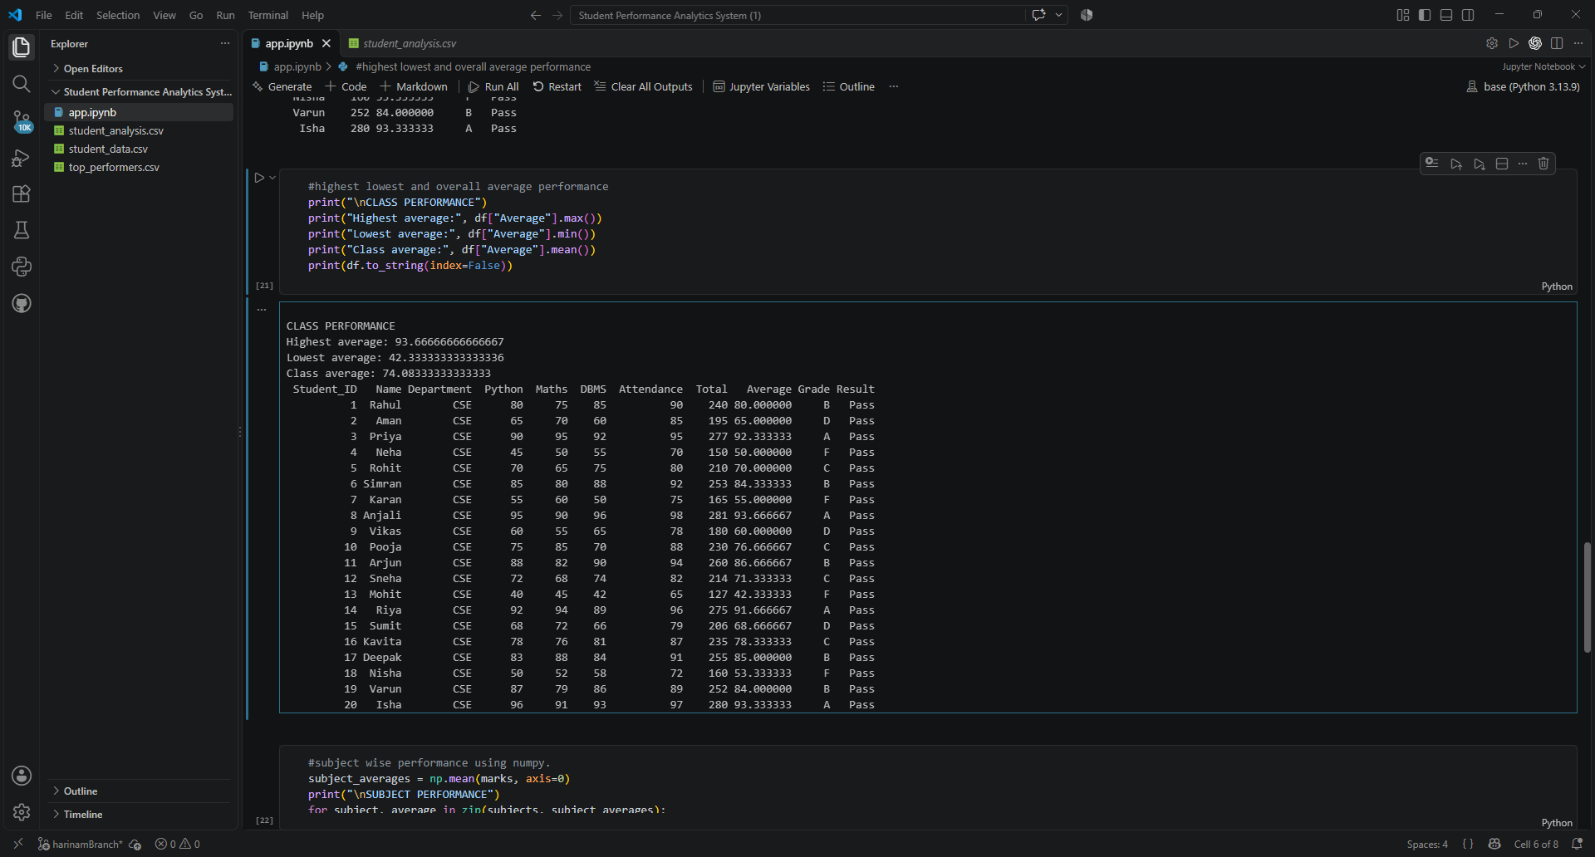
Screenshot 4: Subject-wise performance analysis.
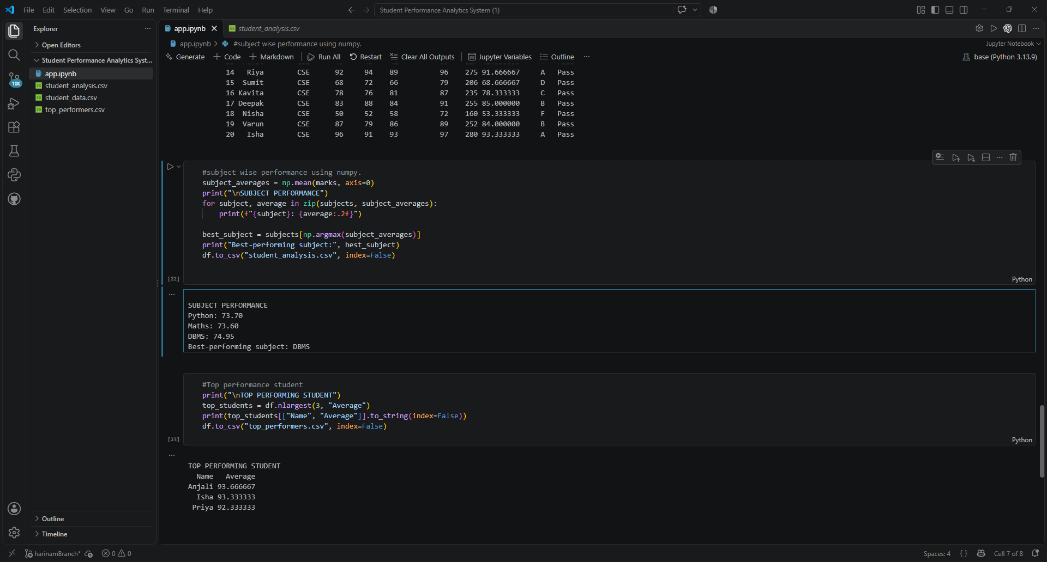
Screenshot 5: Top three performing students.
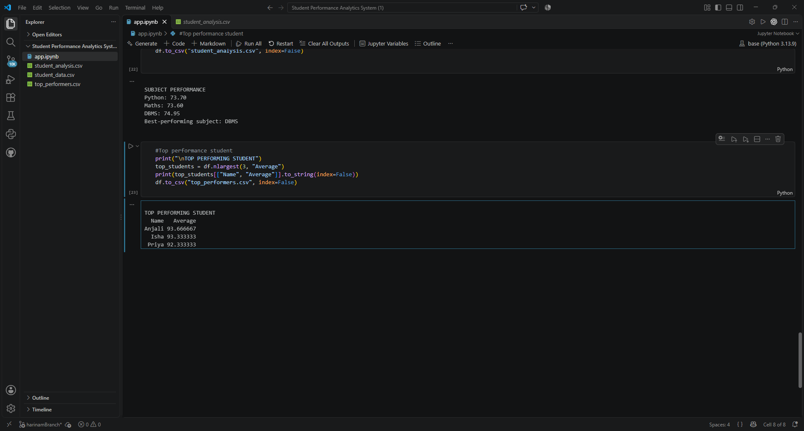

8. Final Outcome
The Student Performance Analytics System processes and analyzes student data using Python, Pandas, and NumPy. It calculates total marks, average marks, grades, and pass/fail results; identifies high- and low-performing students; calculates the class average; compares subject-wise performance; and displays the top three students. The project demonstrates how programming and data-analysis libraries can convert raw student records into useful information.

9. Challenges & Learning

Challenges Faced
- Creating and organizing a dataset containing multiple student records.
- Loading CSV files correctly using Pandas.
- Understanding NumPy operations and calculating averages.
- Writing functions for grade assignment and pass/fail conditions.
- Finding the highest and lowest student averages.
- Combining all features into one working program.

Learning Outcomes
- Learned how to create and manipulate Pandas DataFrames.
- Learned how to read and write CSV files.
- Practised NumPy numerical operations.
- Practised functions, loops, conditions, and variables in Python.
- Learned how to analyse student performance using data.
- Gained experience organising a Python project for GitHub.

10. GitHub Repository
Repository Name: student-performance-analytics
GitHub Repository Link: [Paste Your GitHub Repository URL Here]
The repository should contain the Python source code, student dataset, analyzed output file, README.md, and this project documentation. Replace the placeholder above with the actual repository URL after uploading the project.

